**Android Application that creates an alert upon receiving a message**

Aim:

        To develop a Android Application that creates an alert upon receiving a message.

Procedure:

Creating a New project:

* Open Android Studio and then click on **File -> New -> New project.**

[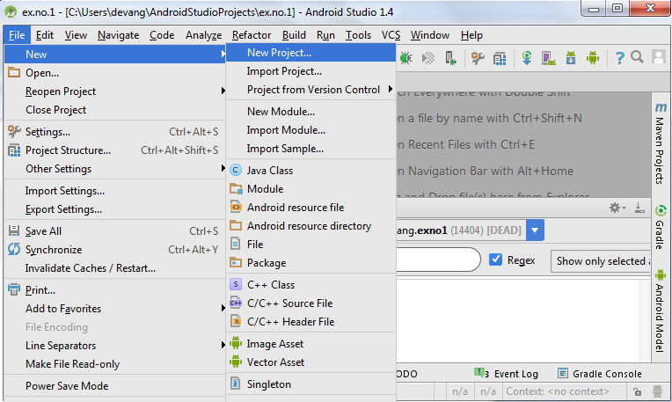](https://codingconnect.net/wp-content/uploads/2016/02/new-project.png)

* Then type the Application name as “**exno9″** and click **Next.**
* Then select the **Minimum SDK** as shown below and click **Next**.
* Then select the **Empty Activity**and click **Next.**
* Finally click F**inish**.
* It will take some time to build and load the project.
* After completion it will look as given below.

Creating Second Activity for the Android Application:

* Click on **File -> New -> Activity -> Empty Activity.**
* Type the Activity Name as **SecondActivity**and click **Finish** button.
* Thus Second Activity For the application is created.

Designing layout for the Android Application:

* Click on **app -> res -> layout -> activity_main.xml.**
* Now click on **Text** as shown below.

Experiment 9-

**MainActivity.java**  
 package com.example.exno9;  
  
import android.app.Notification;  
import android.app.NotificationManager;  
import android.app.PendingIntent;  
import android.content.Intent;  
import android.os.Bundle;  
import android.view.View;  
import android.widget.Button;  
import android.widget.EditText;  
  
import androidx.appcompat.app.AppCompatActivity;  
  
public class MainActivity extends AppCompatActivity  
{  
 Button notify;  
 EditText e;  
 @Override  
 protected void onCreate(Bundle savedInstanceState)  
 {  
 super.onCreate(savedInstanceState);  
 setContentView(R.layout.*activity_main*);  
  
 notify= (Button) findViewById(R.id.*button*);  
 e= (EditText) findViewById(R.id.*editText*);  
  
 notify.setOnClickListener(new View.OnClickListener()  
 {  
 @Override  
 public void onClick(View v)  
 {  
 Intent intent = new Intent(MainActivity.this, SecondActivity.class);  
 PendingIntent pending = PendingIntent.*getActivity*(MainActivity.this, 0, intent, 0);  
 Notification noti = new Notification.Builder(MainActivity.this).setContentTitle("New Message").setContentText(e.getText().toString()).setSmallIcon(R.mipmap.*ic_launcher*).setContentIntent(pending).build();  
 NotificationManager manager = (NotificationManager) getSystemService(*NOTIFICATION_SERVICE*);  
 noti.flags |= Notification.*FLAG_AUTO_CANCEL*;  
 manager.notify(0, noti);  
 }  
 });  
 }  
}

activity_main.xml

<?xml version="1.0" encoding="utf-8"?>  
<LinearLayout xmlns:android="http://schemas.android.com/apk/res/android"  
 android:layout_width="match_parent"  
 android:layout_height="match_parent"  
 android:layout_margin="10dp"  
 android:orientation="vertical">  
  
 <TextView  
 android:layout_width="wrap_content"  
 android:layout_height="wrap_content"  
 android:text="Message"  
 android:textSize="30sp" />  
  
 <EditText  
 android:id="@+id/editText"  
 android:layout_width="match_parent"  
 android:layout_height="wrap_content"  
 android:singleLine="true"  
 android:textSize="30sp" />  
  
 <Button  
 android:id="@+id/button"  
 android:layout_width="wrap_content"  
 android:layout_height="wrap_content"  
 android:layout_margin="30dp"  
 android:layout_gravity="center"  
 android:text="Notify"  
 android:textSize="30sp"/>  
  
</LinearLayout>

**SecondActivity.java**

package com.example.exno9;  
  
import androidx.appcompat.app.AppCompatActivity;  
  
import android.os.Bundle;  
  
public class SecondActivity extends AppCompatActivity {  
  
 @Override  
 protected void onCreate(Bundle savedInstanceState) {  
 super.onCreate(savedInstanceState);  
 setContentView(R.layout.*activity_second*);  
 }  
}

**activity_second.xml**

<?xml version="1.0" encoding="utf-8"?>  
<androidx.constraintlayout.widget.ConstraintLayout xmlns:android="http://schemas.android.com/apk/res/android"  
 xmlns:app="http://schemas.android.com/apk/res-auto"  
 xmlns:tools="http://schemas.android.com/tools"  
 android:layout_width="match_parent"  
 android:layout_height="match_parent"  
 tools:context=".SecondActivity">  
  
</androidx.constraintlayout.widget.ConstraintLayout>

**Output-**